**Dr Nigel Richard Tufft. BSc. MB. ChB. FRCA. FFICM.**

**Expert Witness in Anaesthesia and Intensive Care Medicine.**

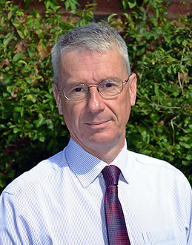

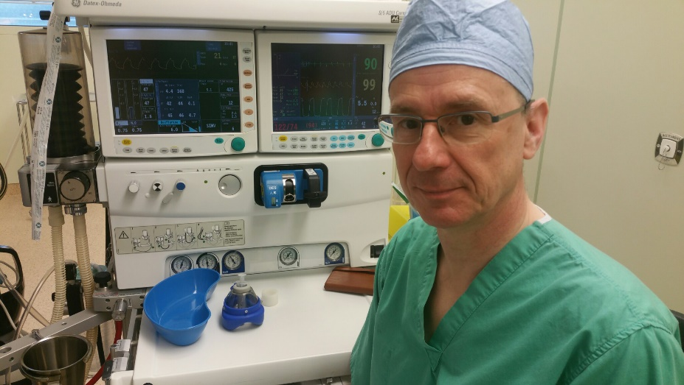

* Dr Tufft has practiced anaesthesia for more than 30 years and has been a consultant for almost 25 years.
* He has diverse experience in both adult anaesthesia and intensive care.
* During the Covid pandemic he volunteered to return to full time intensive care.
* From March 2022 he has paused his clinical work to undertake medicolegal work.

**Previous Positions.**

* Consultant anaesthetist, Robert Jones and Agnes Hunt Orthopaedic Hospital, Oswestry 2017-2022.
* Consultant in intensive care medicine and anaesthesia Shrewsbury and Telford Hospitals NHS Trust, 1998 to 2017.
* Part time Consultant Anaesthetist HSS Kelfavik Iceland. 2015-1019.

**Medical Qualifications.**

* BSc. Degree in Physiology 2/1 Bristol University1985.
* Medical Degree MB. ChB. Bristol University 1988.
* Fellow of the Royal College of Anaesthetists 1991.
* Fellow of the Faculty of Intensive Care Medicine RCA. 2012.

**Medicolegal Qualifications.**

* Cardiff University Bond Solon expert witness certificate 2019.

**Membership of professional bodies.**

* General Medical Council No. 3196971.
* Royal College of Anaesthetists.
* Association of anaesthetists.

**Regulation and insurance.**

* **I was revalidated by the GMC in October 2018.**
* **I have had full registration with the GMC since August 1989.**
* **I am insured by the Medical Protection Society for both clinical and expert witness work.**

**Medico Legal Practice.**

I have been engaged in medicolegal work since 2015.

I offer the full range of medicolegal services including breach of duty and causation reports; condition and prognosis reports, meetings with solicitors and counsel and court attendance if required.

I am happy to offer expert opinion on adult anaesthesia and intensive care for both claimant and defence.

I am particularly interested in the deteriorating patient. I am able to provide mortality estimates for patients at the time they were, or should have been admitted to intensive care.

I am also developing an interest in the Post Intensive care Syndrome. This is the physical, cognitive and psychological problems that survivors of intensive care may suffer from.

Though much of my work is desktop reporting I am happy to see patients either locally to me or in their own homes.

**Anaesthesia Practice.**

As a consultant for 20 years my anaesthetic practice has included almost all of the specialties one would expect to find in a district general hospital. These include; elective and emergency general surgery; thoraco-abdominal oesophagectomy surgery; laparoscopic upper GI surgery; urology; and breast surgery.

I have also anaesthetised for maxillo-facial surgery including facial reconstructions and major cancer surgery; ENT surgery including difficult airways, and both emergency and elective gynaecology.

Latterly my anaesthetic practice was in a specialist orthopaedic hospital.

I regularly anaesthetised for hip and knee replacements, spinal surgery and a wide variety of upper and lower limb orthopaedic procedures.

In addition to general anaesthesia I regularly practiced regional and spinal anaesthetic techniques alone or in combination with sedation or general anaesthesia.

I had specific sessions in the pre-operative assessment unit, and I was the clinical lead for pre-operative assessment.

**Intensive care practice.**

I have a wide experience in dealing with adult medical and surgical intensive care patients found in a district general hospital.

I am experienced in invasive and non-invasive ventilation; cardiovascular monitoring and support; haemodialysis and haemofiltration and procedures such as central lines, including dialysis lines, arterial lines; percutaneous tracheostomy and mini-tracheostomy.

I am particularly interested in the deteriorating patient and introduced the VitalPAC electronic charting and early warning scoring system to Shrewsbury and Telford Hospitals NHS Trust.