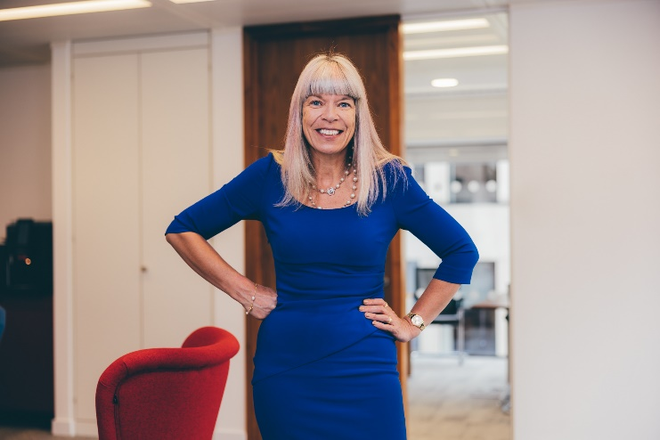

Career History
- Forensic Services Partner, FRP Advisory (2020 to present)
- Director, Walton Dodge Forensic (2019 to 2020)
- Director, JDC Corporate Finance (2019 to 2020)
- Forensic Partner, Ensors Accountants LLP (2014 to 2019)
- Partner, Kreston Reeves LLP (2012 to 2014)
- Partner Crowe Clark Whitehill LLP (2010 to 2012)
- Partner, MRI Moores Rowland LLP and Mazars LLP (1998 to 2010)
- Partner, Thickbroom Coventry (1993 to 1998)
- Qualified Manager CTA, Bradshaw John (1991 to 1993)
- Qualified ACA, KPMG, (1987 to 1990)
Professional qualifications
- Fellow of the Institute of Chartered Accountants (FCA)
- Chartered Tax Adviser (CTA)
- Member of the Academy of Experts (MAE)
- Accredited Counter Fraud Specialist (ACFS)
Education
- BSc (Hons), Nutrition, (Surrey)
- Trained as a Single Joint Expert
Fiona Hotston Moore
Partner
Forensic Services
Cambridge/London/Norwich
+44 (0) 1603 703173
+44 (0) 7770 642491
fiona.hotstonmoore@frpadvisory.com

Peers and clients say “Fiona gets straight to the key points and is superb at explaining complex matters clearly and simply”. Recommended Expert Witness Whos Who Legal

Summary
Fiona is a partner of FRP's Forensic Services practice. Fiona specialises in commercial disputes, business valuations, tax disputes, personal injury and professional negligence matters including giving evidence in the High Court, Family Court, Arbitration and Tax Tribunal. She has been instructed as an Expert in approximately 300 cases in her career to date.
Fiona is also often instructed to provide expert opinion on a range of matters including shareholder disputes, agency disputes and insurance claims, tax disputes (including EBTs, film schemes, entrepreneurs’ relief and Generally Accepted Accounting Practice), officer and employee fraud, auditor and tax adviser professional negligence claims.
Fiona has over 25 years experience providing strategic, accounting, tax and corporate finance advice in a variety of sectors. Fiona’s clients have included successful entrepreneurs, start-ups, international groups and household names
The practical experience that Fiona has as a corporate finance and practicing tax professional perfectly complements her experience as an expert in commercial disputes in Court proceedings - and vice versa.
Fiona has presented both nationally and internationally at conferences for professional training companies, Resolution, the Law Society on matters ranging from share valuation, professional negligence, financial reporting and taxation.
Contributor to Kogan Page textbook “Forensic Accounting & Finance”.

