**Jan 2022**

**Brief CV : Details of Experience and Qualifications**

Rod Appleyard is a Chartered Building Surveyor and independent professional, in practice as a building surveyor specialising in fenestration and building envelope. Scope includes construction and fenestration defects, contractual and specification matters, construction related personal injury including accidents with glass. Rodney Appleyard also acts as either Arbitrator or adjudicator of disputes between householders and their contractors or clients/ contractors with contractors. He has also undertaken training and passed the requirements to be listed as an 'Accredited Mediator' and being certified to give expert evidence in the Scottish Courts..

Has been appointed directly or through the RICS as Arbitrator, Adjudicator and Expert Determiner on a number of occasions for both domestic and commercial disputes. Is the listed Arbitrator for the 'Certass' panel, and an ad-hoc Arbitrator or Mediator appointed by the parties. Has on a number of occasions acted as both an Expert Determiner also third surveyor in party wall disputes.

**1. Technical, Academic and Professional Qualifications.**

2021. **AUEW.** Aberdeen University accredited Expert Witness (Faculty of Law) for Scottish Courts. I hold the University of Aberdeen Bond Solon (UABS) Expert Witness Certificate (2021).This was achieved through extensive study of Scottish Law and culminating in intensive examination with a 95% pass, covering report writing court room skills cross examination and procedure. 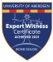

2018. Awarded Lifetime Achievement Award by the Forensic and Building Surveying Federation for services to Fenestration.

2017 Enrolled into **Prime Dispute as a Fellow (FPD)** by way of experience and exam. 

2015 Assessed and tested by way of examination for competence and awarded the status of **Accredited Mediator.**  **F:\logos\2021 Logo_CMC Registered Mediator.png**

2014 Chartered Builder. Assessed and tested for competence and awarded the status of **Chartered Builder/Project Manager** of the CIOB.

1012-2013. Responsible for the updating of the **Yorkshire Arbitration Scheme** and writing the methodology and guidance notes, while heading up the re launch on the internet with on line appointment capabilities.

2010 **FRICS.** Passed the assessment and academic requirements to progress to and awarded the title of Fellow of the Royal Institution of Chartered Surveyors. Regulated by the RICS

2010 **FCIArb.** Met the academic requirements to progress to a Fellow of the Chartered Institute of Arbitrators.

2008 **MSc** - Master of Science in Construction Law. Leeds Metropolitan University

2007 **MBINDT**. Member of the Institute of None-Destructive Testing. (Roll No. 009654)

2006 **MCIOB** Met the academic requirements to progress to a Chartered Member of the Chartered Institute of Building (Roll No 1471934).

2006 **CUEW.** Cardiff University accredited Expert Witness (Faculty of Law) Diploma. 

2006 **Certified Thermo-Graphic Surveyor**. (Roll No 2006UK28No16)

2005 **BSc(Hons)** - Bachelor of Science, Building Surveying, Leeds Metropolitan University

2005 **ICIOB** - Incorporated Member, Chartered Institute of Building (Roll No. 1471934).

2001 **ACIArb** - Associate Member, Chartered Institute of Arbitrators (Roll No 19139)

1998 **Expert Witness Competency Certificate** - Bond Solon Legal Training & Royal Institution of Chartered Surveyors.

1998 **TechRICS** - Technical Surveyor, Royal Institution of Chartered Surveyors (Roll No. 11056046), following merger with **SST**

1994 **Certified Inspector** - Loss Prevention Certification Board (Fenestration and Construction practice inspections)

1994 **MSST** - Member, Society of Surveying Technicians (absorbed into RICS) (Roll No 6126753)

1994 **NVQ DBTL 35** - External Assessor GTL, Sheffield.

**2. Appointments**

1994- To present:- Regularly appointed as either a single expert or joint expert in a wide variety of construction disputes where a technical opinion is required. Maintains a firm understanding of all aspects of construction and construction houses in own right, RA is registered with the NHBC as a developer and as such is aware of current standards requirements, maintaining an extensive reference library to call on.

2001 -To present:- Appointed to carry out pre-construction review of projects, including liaising with Architects to prevent expensive errors during the build process inclusive of on- site monitoring, for several national construction companies.

2006 To present:- Retained by one of the largest national privately owned, construction and development companies as external consultant in respect of building defect's rectification.

2018 Construction consultant, TV Chanel 5 Ester Ransen's 'House Trap 2'

2006 Construction consultant, BBC's "Rogue Trader".

2004/2005 Construction consultant, BBC's "Watchdog", “Rogue Trader” & ITV's "House of Horrors"

2000- RICS Adjudication panel member, domestic disputes.

2000-Present, Regularly appointed either through panels or direct as Arbitrator of disputes.

**3. Experience**

2017-2021 Chair of The United Kingdom Thermograph Association (UKTA) commissioned to restarting and creating a working group within the BINDT condition monitoring faculty, being a dormant entity.

2018-2018 Chair of North East Branch of the Chartered Institute of Arbitrators.

2013-2015 Chair of North East Branch of the Chartered Institute of Arbitrators.

2014. Delivery of Lectures to law students and the like, on the benefits of ADR and the application of such mechanism

2013-2014 Headed up the re-write the 'Yorkshire Arbitration Scheme' and headed up the re-launch in 2014.

1994- Professional Practice (Verification Associates) - independent consultancy specialising in fenestration and building envelope defects and contractual disputes, providing expert witness services, domestic and commercial including glass related personal injury.

2011-2013 Research in field and by other avenues to establish benefit of quadruple glazing against double and triple glazing. Using thermographic and established data. This research considered weight, heat gain, material type and both thermal efficiency and acoustic performance. This product is now being sold in Scotland as a commercial venture by others. Hypothesis was proven in 2014 with a certified result by a third party 2015.

2004-2006 Appearances in television consumer programmes including "Watchdog", "House of Horrors", “Rogue Trader”.

2004/2005 Autumn/Winter BBC Radio Leeds' John Boyd Show - "phone-in" for construction problems.

2002-2004 Preparation and delivery of training lectures for Fenestration and Construction industry operatives and surveyors - national companies and Glass Training Limited (Sheffield)

1996-1998 West Yorkshire Trading Standards seminar team member, expert speaker on fenestration.

1994 Compilation (with others) of documents for window industry NVQ standards for surveyors (in firm).

1974-1994 Proprietor and principal surveyor of a large regional glass, glazing and window replacement company engaged in most aspects of the fenestration industry, domestic and commercial.

1971-1974 Junior General Foreman, Wimpey Construction, Finishing Foreman, Marshall Construction, Elland

**4.** **Other Information**

1. Listings as "Checked Expert Witness" in Law Society Handbook, "Fenestration Expert" in Waterlow directory (see "Registered Expert Witness "RICS/EWI Scheme (Roll No 1404)) 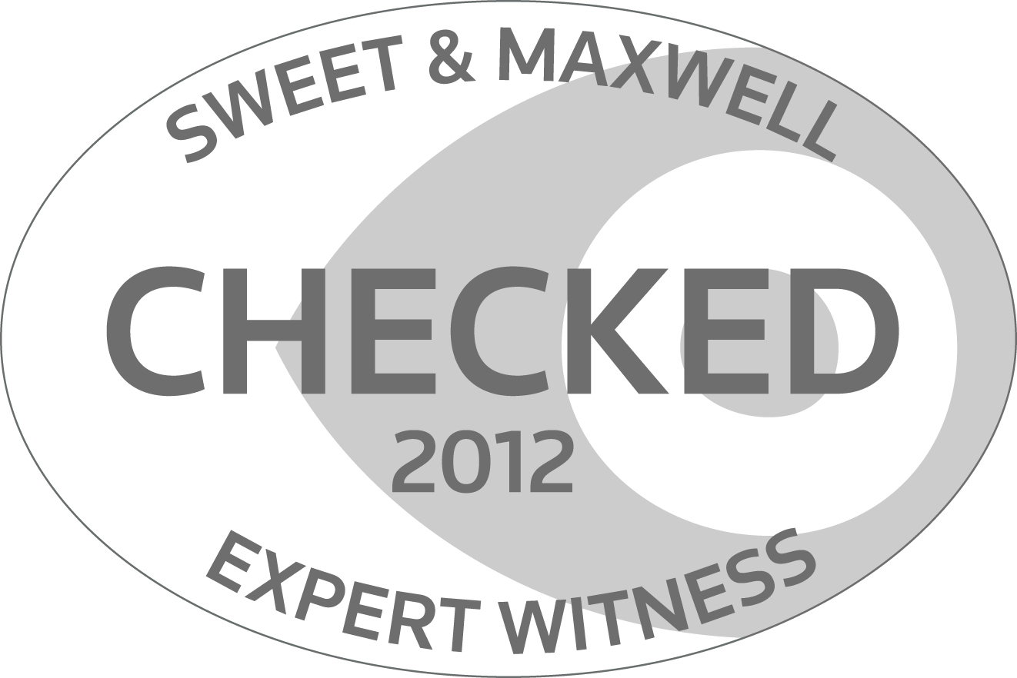

2. Listed as a checked Expert Witness with the Law Society of Scotland. 

3. 2009- Present: Acted as, Arbitrator/Adjudicator/Mediator in construction disputes to date.

4. 2003-2006 Bi-monthly column in leading industry journal "Glass Age"

5. Published in 'Building', RICS 'Modus' and CIArb 'Resolver',

6. Experience in the delivery of information as court expert witness and lecturer

7. Strong interest in conservation - particularly listed buildings/stained glass

8. 100% marks (highest awarded in 30 years) in LMU, BSc module "Conservation and Construction Principles".

9. Listed as either, Arbitrator or Adjudicator on the following dispute appointment panels RICS Adjudication, CIArb Property Panel, Certass.

10. 2019 Awarded a 'Life Time Achievement' award by the Federation of Forensic and Expert Witnesses for Expert Witness Services to Fenestration and Building Surveying.